Alien flora of Calabria (Southern Italy): an updated checklist – BIOLOGICAL INVASIONS

Giovanni Spampinato¹, Valentina Lucia Astrid Laface¹, Giandomenico Posillipo¹, Ana Cano Ortiz², Ricardo Quinto Canas^{3,4}, Carmelo Maria Musarella^{1*}
¹ Dipartimento di AGRARIA, Università Mediterranea di Reggio Calabria, Loc. Feo di Vito snc, 89122 Reggio Calabria, Italy
² Department of Animal and Plant Biology and Ecology, Section of Botany, University of Jaén, 23071 Jaén, Spain
³ Faculty of Sciences and Technology, University of Algarve, Campus de Gambelas, 8005-139 Faro, Portugal
⁴ Centre of Marine Sciences (CCMAR), University of Algarve, Campus de Gambelas, 8005-139 Faro, Portugal

* Corresponding author: Carmelo Maria Musarella, carmelo.musarella@unirc.it

Online Resource 2
List of the new records at European, Italian and Calabrian level, complete with their scientific name, synonym, family, residence status, native range, life form, type of record, invasive status, specimina visa and note.

- Aeonium arboreum (L.) Webb & Berthel. [Sempervivum arboreum L.]
Crassulaceae, Archaeophyte, Canary Islands, Nanophanerophyte
First record for Calabria (casual)
Specimen: 17th April 2021, Via Provinciale Motta San Giovanni (Reggio Calabria province), roadside, 37.999244°N-15.667214°E, 264 m a.s.l., leg. et det. V.L.A. Laface (REGGIO).
Note. Some plants were observed along a slope, in the midst of plants of Opuntia ficus-indica (L.) Mill., probably derived from gardening waste material thrown away from nearby villas, where the species is cultivated as an ornamental (Fig. 7a,b).
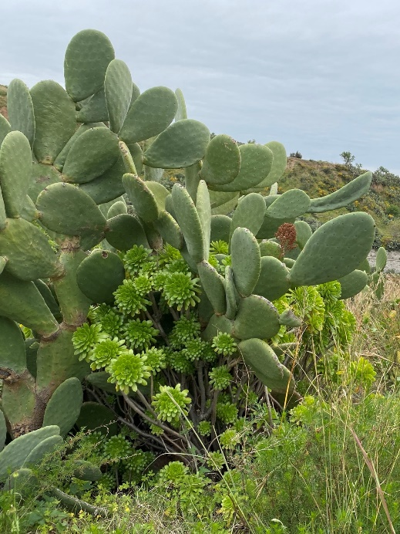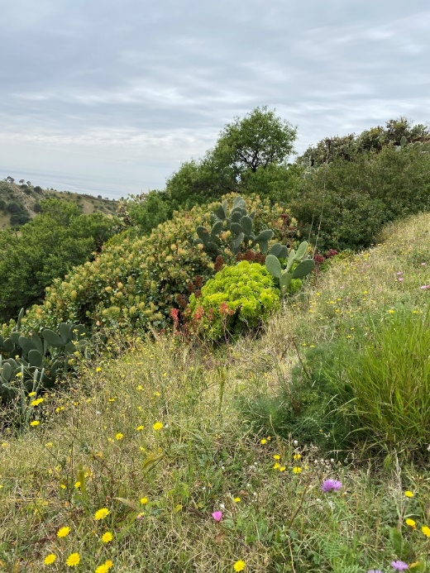

Fig. 7a,b Aeonium arboreum (L.) Webb & Berthel. (a) in the midst of plants of Opuntia ficus-indica (L.) Mill., along Provinciale Street and (b) on a slope near a villa in Motta San Giovanni (Reggio Calabria province) - Ph. VLAL.
- Asparagus asparagoides (L.) Druce
Asparagaceae, Neophyte, Southern and east Africa, Climbing Phanerophyte
First record for Calabria (casual)
Specimen: 13th January 2021, Via delle Filande, Villa San Giovanni (Reggio Calabria province), wall, 38.217903°N-15.637931°E, 12 m a.s.l., leg. C.M. Musarella, det. C.M. Musarella (REGGIO).
Note. In Italy this species is a casual alien in Campania and Sardegna and naturalized in Sicilia (Galasso et al. 2018a). The observed plant grows in a crack in the wall, probably escaped from the pots on the adjacent balconies where it is used as an ornamental plant (Fig. 8).
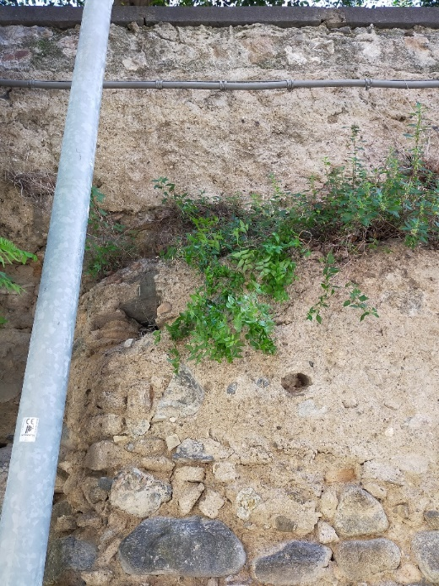

Fig. 8 Asparagus asparagoides (L.) Druce in a crack of a wall in Villa San Giovanni (Reggio Calabria province) - Ph. CMM.
- Aspidistra elatior Blume [Plectogyne variegata Link]
Asparagaceae, Neophyte, Japan, Rhizome Geophyte
First record for Calabria (casual)
Specimen: 2nd April 2021, Pendicu, Ortì di Reggio Calabria (Reggio Calabria province), stream banks, 38.143254°N-15.707500°E, 434 m a.s.l., leg. et det. V.L.A. Laface (REGGIO) (Fig. 9a,b).
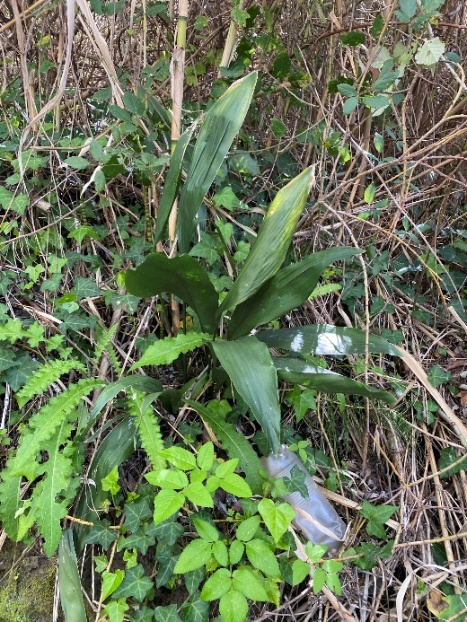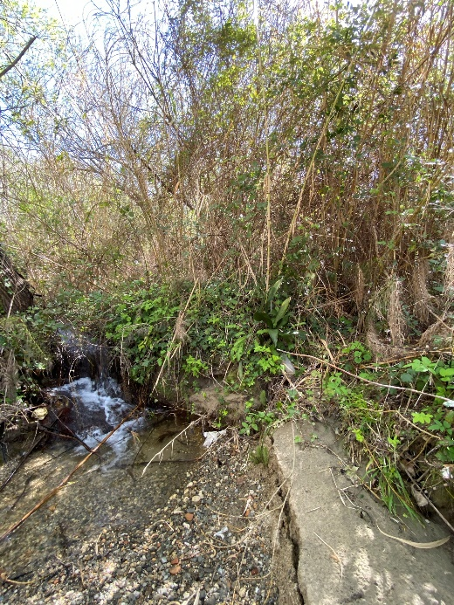

Fig. 9a,b Aspidistra elatior Blume along a stream bank near the village of Ortì in Reggio Calabria (Reggio Calabria province) - Ph. VLAL.
Note. Species native to Japan (POWO 2019), commonly grown as an ornamental plant. According to Galasso et al. (2018a), this species is reported in Italy as casual alien in Liguria, Lombardia, Toscana and Veneto.
- Bidens sulphurea (Cav.) Sch.Bip. [Cosmos aurantiacus Klatt; Cosmos sulphureus Cav.]
Asteraceae, Neophyte, Mexico, Scapose Therophyte
First record for Calabria (casual)
Specimina: 12th September 2020, Melia di San Roberto (Reggio Calabria province), road side, 38.229467°N-15.755077°E, 639 m a.s.l., leg. et det. V.L.A. Laface (REGGIO); 18 July 2021, SS183, Chorio, San Lorenzo (Reggio Calabria province), road side, 37.987261°N- 15.813308°E, 270 m a.s.l., leg. et det. V.L.A. Laface (REGGIO).
Note. Bidens sulphurea (Cav.) Sch.Bip. is cultivated as ornamental plants for beautiful long-lasting flowers (Lorenzi and Souza 2008). The species occurs along roadsides on piles of debris accumulated by the drainage of rainwater. The population observed is composed of thirteen large breeding individuals much branched and some young plants. It grows in a very disturbed habitat, characterized by numerous ruderal, nitrophilous and some alien species (Fig. 10a,b).
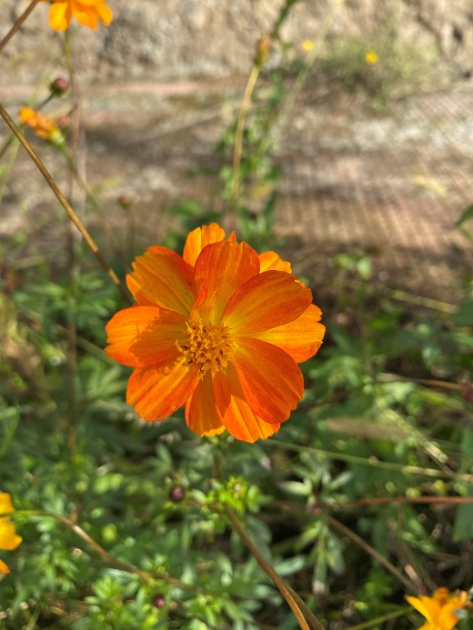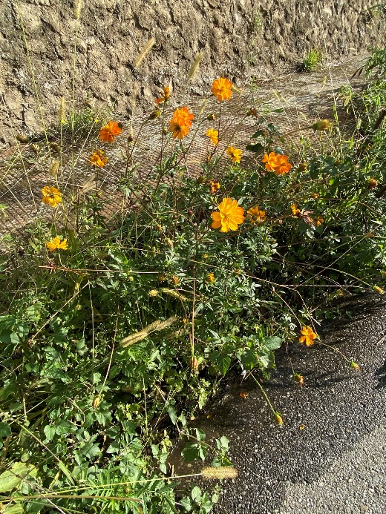

Fig. 10a,b Bidens sulphurea (Cav.) Sch.Bip. along a roadside in Melia of San Roberto (Reggio Calabria province) - Ph. VLAL.
- Camptosema rubicundum Hook. & Arn.
Fabaceae, Neophyte, South America (Argentina Northeast, Bolivia, Brazil, Paraguay, Uruguay), Climbing Phanerophyte
First record for Europe (casual)
First record for Italy (casual)
First record for Calabria (casual)
Specimen: 20th July 2019, Via Consortile, Spontone fraz. di Catona di Reggio Calabria (Reggio Calabria province), slope and roadside, 38.193364°N-15.641431°E, 32 m a.s.l., leg. et det. V.L.A. Laface (REGGIO).
Note. Camptosema rubicundum Hook. & Arn. is native of Southern America (Argentina Northeast, Bolivia, Brazil South, Brazil West-Central, Paraguay, Uruguay) (POWO 2019). Some adult plants grow along an escarpment, among plants of Opuntia ficus-indica (L.) Mill. and they reproduce themselves vegetatively (branches touching the ground produce roots) (Fig. 11a,b). In addition, a few young plants and seedlings were observed, generated by seeds rolling down the escarpment and stopping at the roadside. The species is probably arrived vegetatively from the neighboring villas.
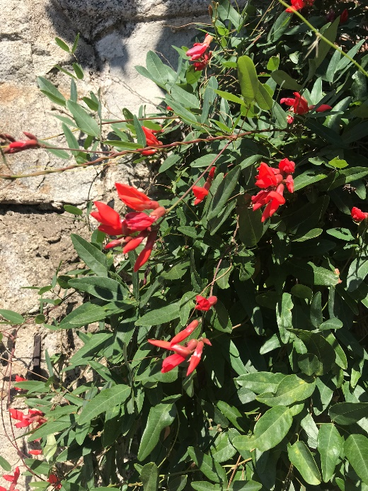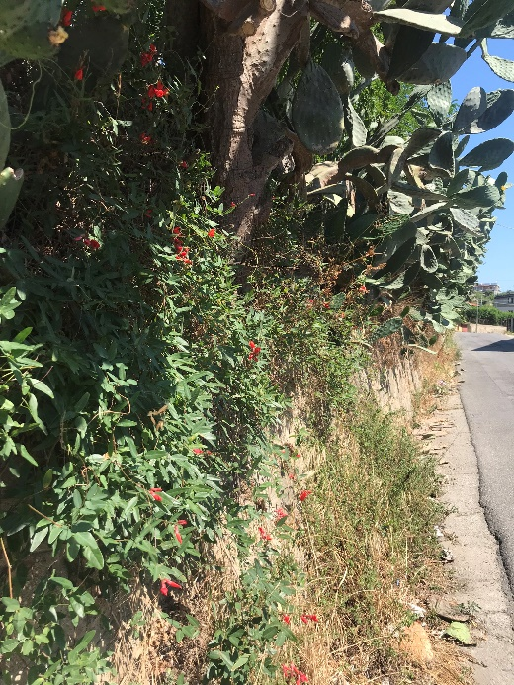

Fig. 11a,b Camptosema rubicundum Hook. & Arn. along Consortile street in Spontone of Catona, Reggio Calabria (Reggio Calabria province) - Ph. VLAL.
- Catalpa bignonioides Walter
Bignoniaceae, Neophyte, North America (Alabama, Florida, Georgia, Louisiana, Mississippi, Texas, Vermont), Scapose Phanerophyte
First record for Calabria (casual)
Specimen: 27th July 2020, Lungomare Momena, Rossano (Cosenza province), sidewalk, 39.620067°N -16.626717°E, 1 m a.s.l., leg. et det. V.L.A. Laface, C.M. Musarella, G. Spampinato (REGGIO).
Note. The individual observed in sidewalk probably derives from some plants that are grown nearby as street trees (Fig. 12).
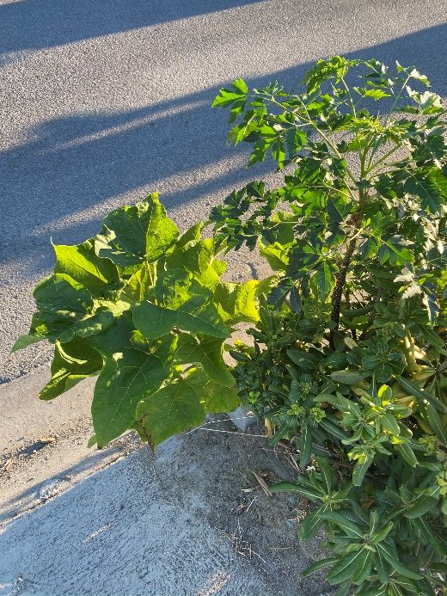

Fig. 12 Catalpa bignonioides Walter along a sidewalk in Rossano seafront (Cosenza province) - Ph. VLAL.
- Citrus ×aurantium L. [Citrus maxima (Burnm.) Merr. × Citrus reticulata Blanco; Citrus ×aurantium L. var. sinensis L.; Citrus ×sinensis (L.) Osbeck;]
Rutaceae, Archaeophyte, South-East Asia, Scapose Phanerophyte
First record for Calabria (casual)
Specimina: 12th February 2021, Parco archeologico urbano di Brancaleone Vetus, Brancaleone Superiore (Reggio Calabria province), ruins, 37.977919°N-16.079328°E, 288 m a.s.l., leg. et det. V.L.A. Laface, C.M. Musarella (REGGIO) (Fig. 13a,b); 16 April 2021, Riace Capo, Saline, Motta San Giovanni (Reggio Calabria province), grassland, 37.951987°N-15.695057°E, 10 m a.s.l., leg. V.L.A. Laface, C.M. Musarella, G. Posillipo, det. V.L.A. Laface, C.M. Musarella (REGGIO).
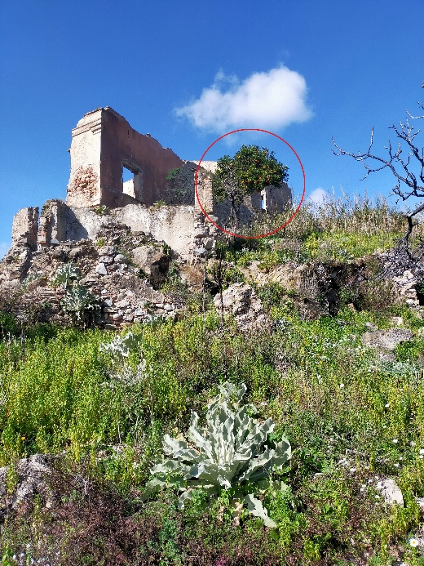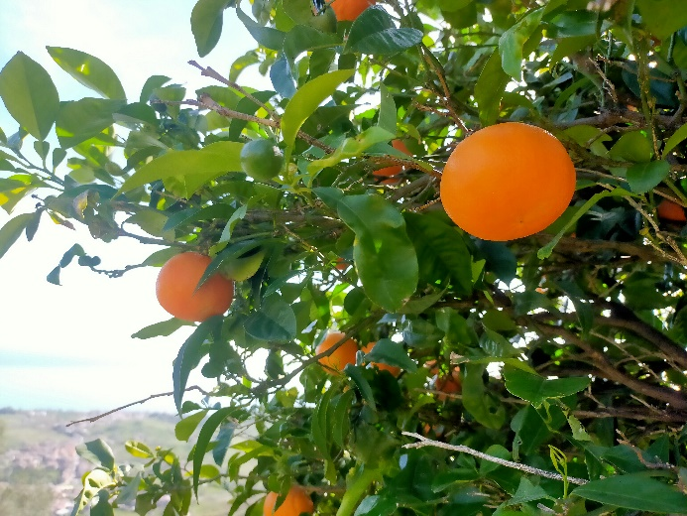

Fig. 13a,b Citrus ×aurantium L. among the ruins of the Urban Archaeological Park of Brancaleone Vetus in Brancaleone Superiore (Reggio Calabria province) - Ph. CMM.
Note. Although Citrus ×aurantium is commonly used as rootstock in citrus cultivation, seedlings are very rarely observed.
- Crassula ovata (Mill.) Druce [Cotyledon ovata Mill.; Crassula argentea Thunb.; Crassula portulacea Lam.]
Crassulaceae, Neophyte, Cape Provinces, KwaZulu-Natal and Mozambique, Succulent Chamaephyte
First record for Calabria (casual)
Specimen: 24th April 2021, Sopraelevata Porto, Reggio Calabria (Reggio Calabria province), rain water drainage channel, 38.121061°N-15.651842°E, 11 m a.s.l., leg. et det. V.L.A. Laface (REGGIO); 20th May 2021, Saracinello, Reggio Calabria (Reggio Calabria province), Uncultivated/abandoned garden, 38.069422°N-15.661267°E, 25 m a.s.l., leg. et det. V.L.A. Laface (REGGIO).
Note: This species is commonly cultivated as an ornamental plant, the individual found was probably derived from plants observed in pots on the balconies of neighbouring houses (Fig. 14a,b).
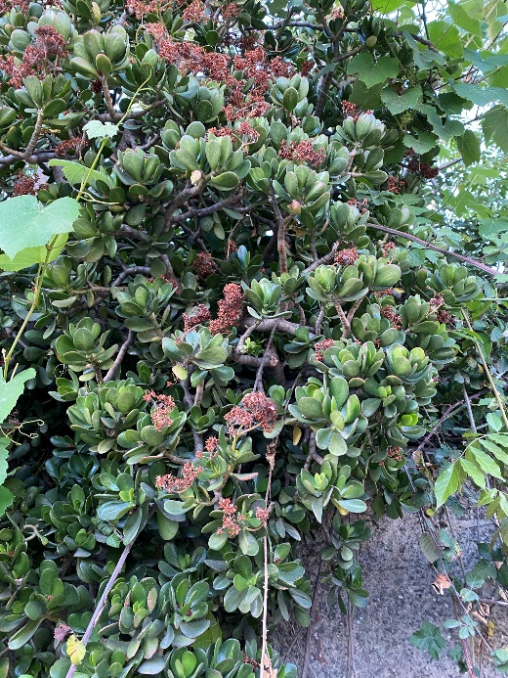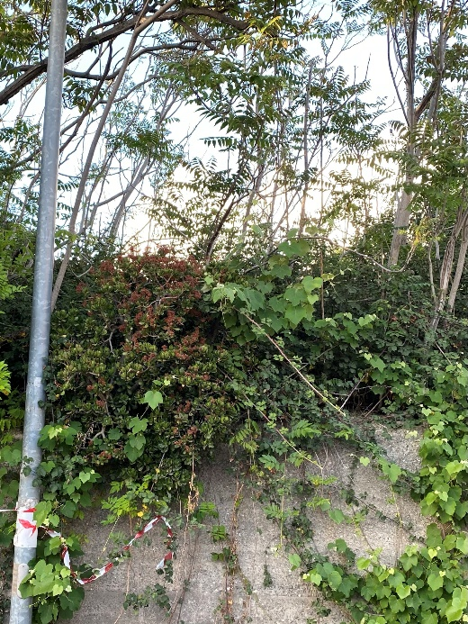

Fig. 14a,b Crassula ovata (Mill.) Druce in Saracinello, Reggio Calabria (Reggio Calabria province) - Ph. VLAL.
- Cucurbita ficifolia Bouché [Pepo ficifolius (Bouché) Britton]
Cucurbitaceae, Neophyte, Bolivia and Peru, Scapose Hemicryptophyte
First record for Calabria (casual)
Specimina: 5th February 2021, Via Provinciale Motta San Giovanni (Reggio Calabria province) road side, 38.000167°N - 15.678736°E, 381 m a.s.l., leg. et det. V.L.A. Laface, C.M. Musarella (REGGIO); 5th February 2021, Leandro, Motta San Giovanni, strada per l'Invaso Scillupia (Reggio Calabria province), artificial stream, 38.015095°N-15.723314°E, 671 m a.s.l., leg. et det. V.L.A. Laface, C.M. Musarella (REGGIO).
Note. The plant is commonly cultivated in the area where it is used as food for domestic animals during the winter (locally called “mbirnitica” zucchini). The individuals found are probably escaped from cultivation in nearby area (Fig. 15a,b). In Italy it is reported exclusively for Trentino Alto Adige as casual alien (Galasso et al. 2018a).
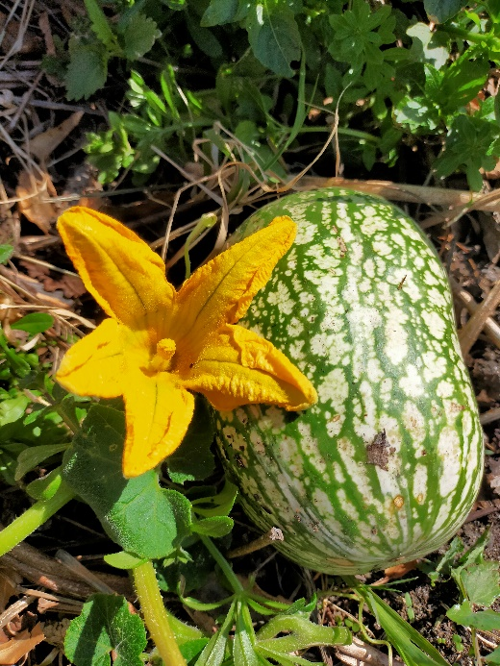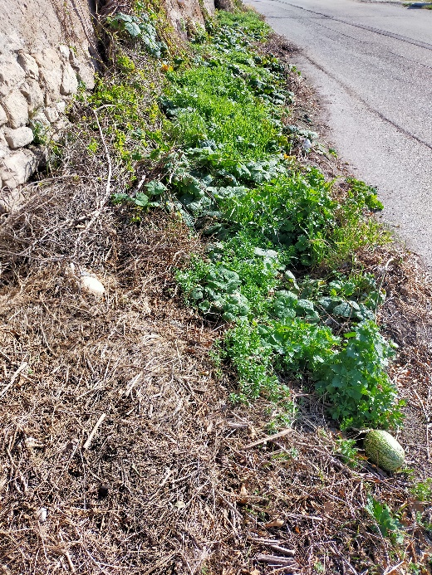

Fig. 15a,b Cucurbita ficifolia Bouché along Provinciale Street in Motta San Giovanni (Reggio Calabria province) - Ph. CMM.
- Dimorphotheca ecklonis DC. [Osteospermum ecklonis (DC.) Norl.]
Asteraceae, Neophyte, Cape Provinces, Scapose Hemicryptophyte
First record for Calabria (casual)
Specimina: 14th September 2020, Annà (Reggio Calabria province), road side, 37.928339°N-15.752464°E, 30 m a.s.l., leg. et det. V.L.A. Laface (REGGIO); 06 March 2021, Via Antonio Blasi, Motta San Giovanni (Reggio Calabria province), road side, 38.000790°N-15.691344°E, 413 m a.s.l., leg. et det. V.L.A. Laface (REGGIO).
Note. The species is native to Africa and has very colourful and striking flowers in spring and summer, which is why it is commonly cultivated as an ornamental species. The plants found were growing in the crack of the asphalt, generated by seeds from plants grown in nearby houses (Fig16a,b). According to Galasso et al. (2018a) it is reported as casual alien in Liguria, Toscana, Abruzzo, Lazio, Molise, and Puglia.
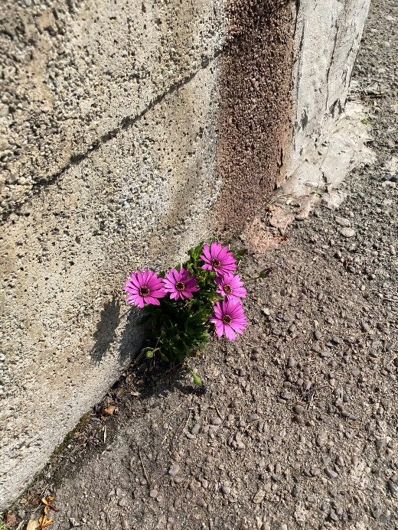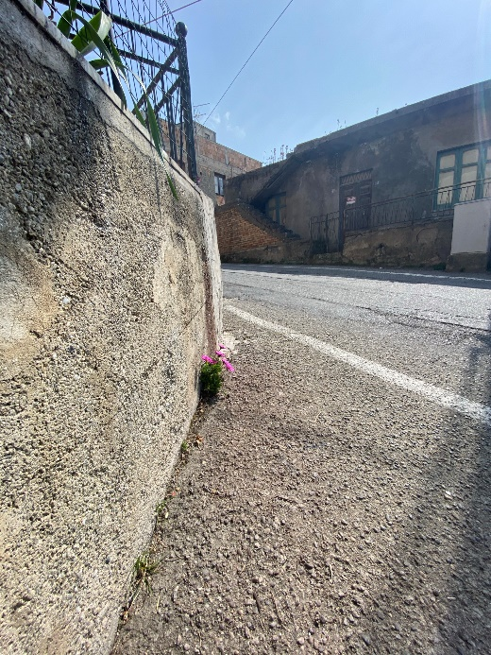

Fig. 16a,b Dimorphotheca ecklonis DC. along Antonio Blasi Street in Motta San Giovanni (Reggio Calabria province) - Ph. VLAL.
- Graptopetalum paraguayense (N.E.Br.) Walther subsp. paraguayense
Crassulaceae, Neophyte, Mexico, Succulent Chamaephyte
First record for Calabria (casual)
Specimen: 24th April 2021, Sopraelevata Porto, Reggio Calabria (Reggio Calabria province), rain water drainage channel, 38.121061°N-15.651842°E, 11 m a.s.l., leg. et det. V.L.A. Laface (REGGIO).
Note. Succulent plant cultivated as an ornamental species, it easily reproduces vegetalely. The individual found growing on the roadside in a rainwater drainage channel (Fig. 17a,b). In Italy it is reported as casual alien in Basilicata, Campania, Lombardia and Sicilia.
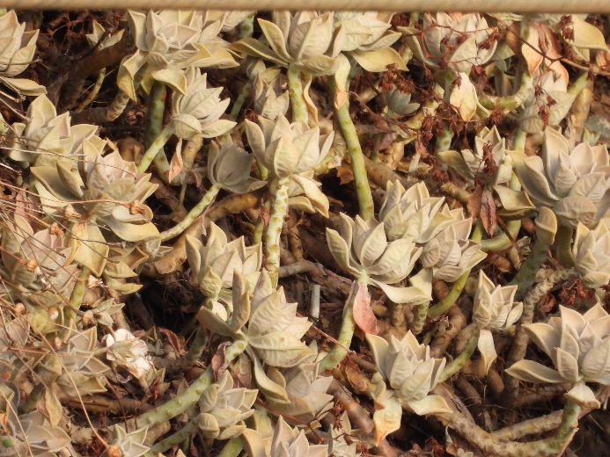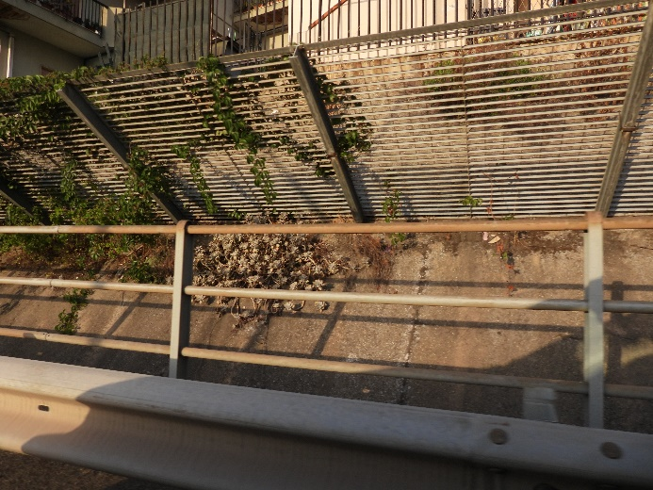

Fig. 17a,b Graptopetalum paraguayense (N.E.Br.) Walther subsp. paraguayense along the causeway of the Port of Reggio Calabria (Reggio Calabria province) - Ph. VLAL.
- Ipomoea hederacea (L.) Jacq. [Cleimera hederacea (Jacq.) Raf.; Cleiemera hirsuta Raf.; Convolvulus caeruleus (Roxb. ex Ker-Gawl.) Spreng.; Pharbitis caerulescens Sweet; Pharbitis hederacea (Jacq.) Choisy]
Convolvulaceae, Neophyte, Mexico, Climbing Therophyte
First record for Continental Europe (casual)
First record for Italy (casual)
First record for Calabria (casual)
Specimen: 31 October 2019, Loc. Manguso, Strada Comunale Amendolea, Condofuri (Reggio Calabria province), roadside and wall climbing, 37.980649°N-15.896695°E, 140 m a.s.l., leg. et det. V.L.A. Laface (REGGIO).
Note. A native species of Mexico (POWO 2019), it commonly grows in temperate regions of the United States of America and Canada and has also been reported in Cuba (Wood et al. 2020). Sell and Murrell (2009), report this species as adventitious in southern England (Europe). The observed species grows along the roadsides, climbing a stone wall. The population composed 5 breeding individuals grows in a disturbed habitat, characterized by numerous ruderal and nitrophilous species as Parietaria judaica L., Oloptum miliaceum (L.) Röser & H.R.Hamasha, Rumex crispus L., Setaria sp., Sonchus oleraceus L. and other species as Ipomoea purpurea (L.) Roth, Trifolium campestre Schreb., T. repens L., and some alien species, such as Amaranthus retroflexus L., Oxalis pes-caprae L., Erigeron bonariensis L. The individuals found are probably escaped from cultivation in nearby villas (Fig. 18a,b).
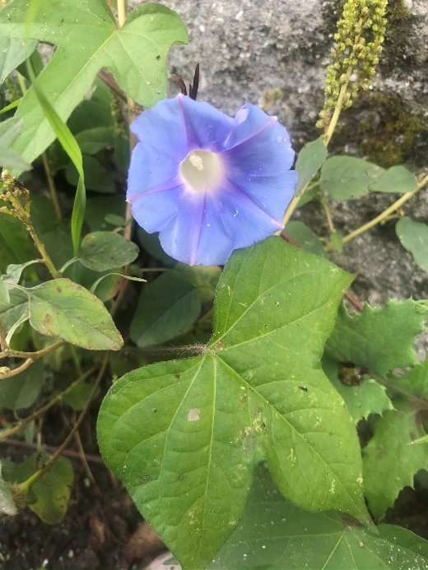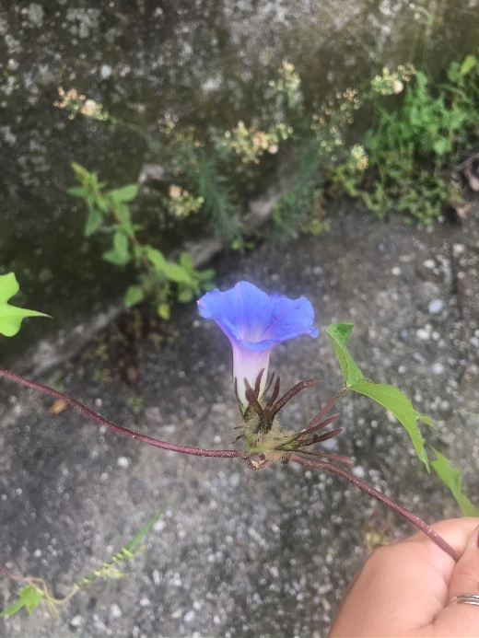

Fig. 18a,b Ipomoea hederacea (L.) Jacq. climbing a stone wall along the municipal road Amendolea, Condofuri (Reggio Calabria province) - Ph. VLAL.

- Kalanchoë laxiflora Baker
Crassulaceae, Neophyte, Madagascar, Succulent Chamaephyte
First record for Calabria (casual)
Specimen: 3rd May 2021, Via Provinciale Spirito Santo, Prumo, Reggio Calabria (Reggio Calabria province), road side, 38.102347°N-15.679361°E, 131 m a.s.l., leg. et det. V.L.A. Laface (REGGIO).
Note. This plant native to Madagascar (POWO 2019), is commonly grown as an ornamental species. Recently, this species was reported for the first time to Basilicata region, confirming its presence to Europe and Italy (Stinca et al. 2021). The observed plant grows in a crack of a bordering wall. The individual observed probably came from the seeds of some plants on the balconies of the houses adjacent to the road (Fig. 19).
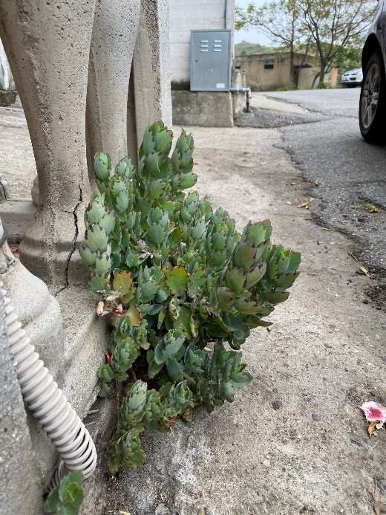

Fig. 19 Kalanchoë laxiflora Baker along Provinciale Street in Spirito Santo, Prumo, Reggio Calabria (Reggio Calabria province) - Ph. VLAL.
- Musa × paradisiaca L.
Musaceae, Neophyte, Malesia and Philippines, Rhizome Geophyte
First record for Europe (casual)
First record for Italy (casual)
First record for Calabria (casual)
Specimina: 10-01-2020, Fiumara lungo la strada tra Agraria ed Ingegneria (Reggio Calabria province), river bed, 38.120048°N-15.666487°E, 84 m a.s.l., leg. V.L.A. Laface et G. Posillipo, det. V.L.A. Laface et C.M. Musarella (REGGIO); 11-01-2020, tra S.S.106 Jonica e binari della ferrovia (Reggio Calabria province), abandoned field, 37.954395°N-16.092609°E, 7 m a.s.l., leg. et det. V.L.A. Laface (REGGIO).
Note. Evergreen tropical plant native to Malaya, Philippines, cultivated worldwide as an ornamental plant and for the production of its fruits (bananas), naturalised in many tropical states (POWO 2019). M. × paradisiaca is the hybrid between M. acuminata e M. balbisiana (Karamura 1998; Molina and Roa 2000). The presence in Calabria is attributable to vegetative reproduction: very often pieces of roots are thrown away together with the waste materials accumulated during the cleaning of the gardens. The plants here reported grow on accumulations of waste material or in a river bed where sediment and twigs are accumulated (Fig. 20a,b,c).
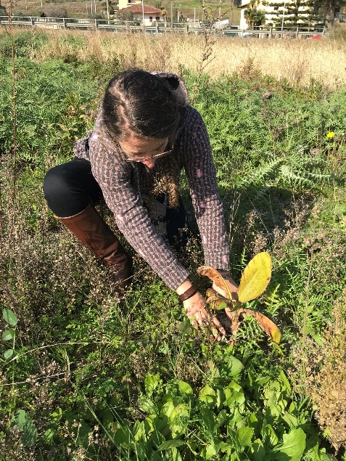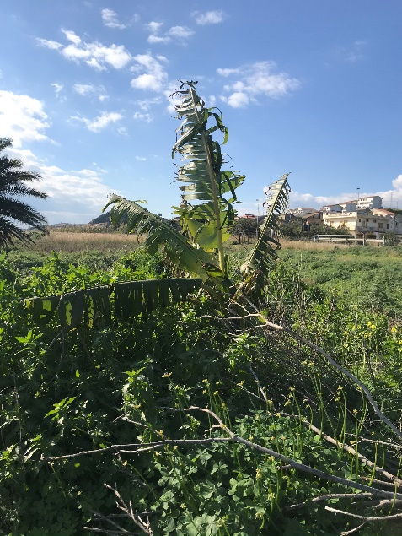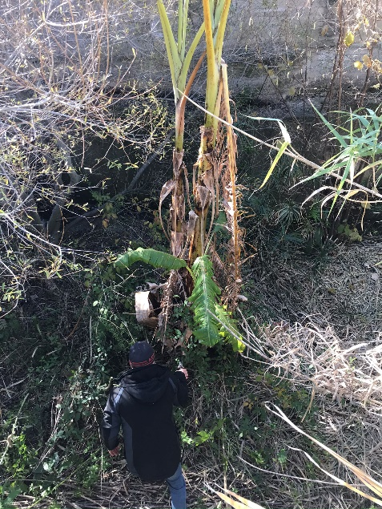

Fig. 20a,b,c Musa × paradisiaca L. (a-b) in abandoned fields near Brancaleone; (c) in the bed of the fiumara between the Agricolture and Engineering Departments of Reggio Calabria (Reggio Calabria province) - Ph. VLAL.
- Nicotiana tabacum L.
Solanaceae, Neophyte, Bolivia, Scapose Hemicryptophyte
First record for Calabria (casual)
Specimen: 1st April 2021, Lazzaro, Motta San Giovanni (Reggio Calabria province), side walk, 37.974286°N-15.664644°E, 18 m a.s.l., leg. et det. C.M. Musarella (REGGIO).
Note: In Italy this species is reported as casual alien in Campania, Lazio, Piemonte, Sardegna, Sicilia, Trentino-Alto Adige and Umbria (Galasso et al. 2018a). The observed plant grows in a crack between sidewalk and wall (Fig. 21a,b). In the same area have been observed, in the past, other alien species: Commelina erecta L. and Nothoscordum gracile (Aiton) Stearn (Rosati et al. 2020; Laface et al. 2020).
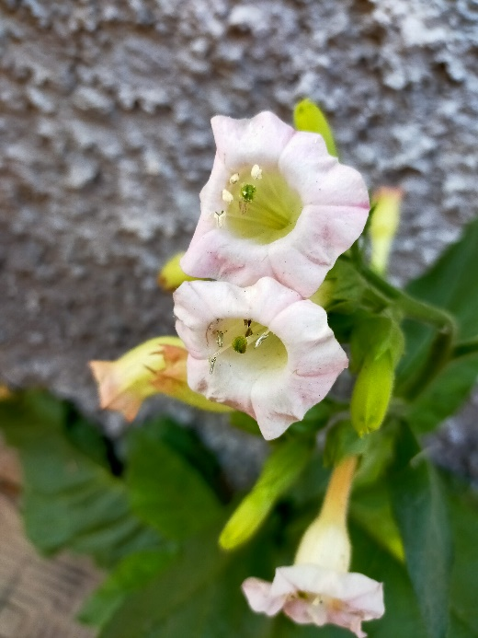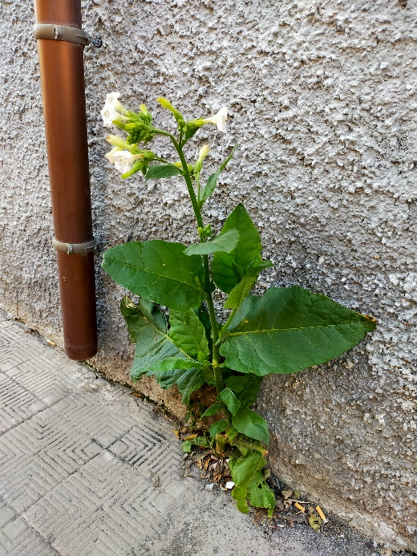

Fig. 21a,b Nicotiana tabacum L. on a sidewalk in Lazzaro of Motta San Giovanni (Reggio Calabria province) - Ph. CMM.
- Pelargonium graveolens (Thunb.) L’Hér. [Geranium graveolens Thunb.]
Geraniaceae, Neophyte, East Zimbabwe to East Cape Provinces, Suffruticose Chamaephyte
First record for Italian Peninsula (casual)
First record for Calabria (casual)

Specimen: 10th April 2021, Collina di Pentimele, Reggio Calabria (Reggio Calabria province), pine forest, 38.134708°N-15.671089°E, 300 m a.s.l., leg. et det. V.L.A. Laface (REGGIO).
Note: The observed plants grow abundantly in a pine forest, next to a ruin (Fig. 22a,b). According to Galasso et al. (2018a), in Italy this species is reported as casual alien exclusively in Sardinia.
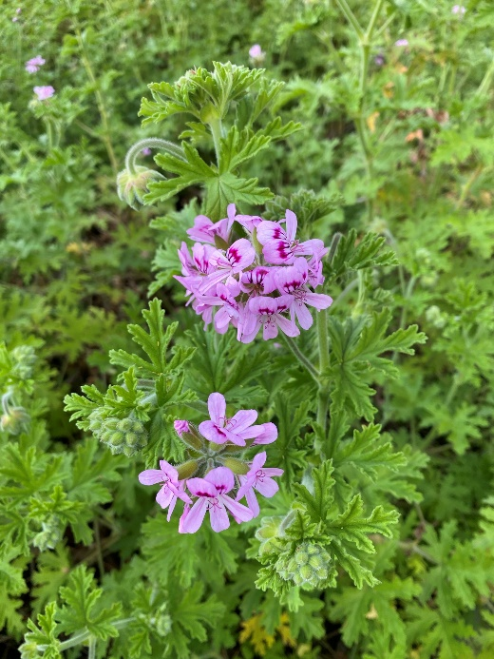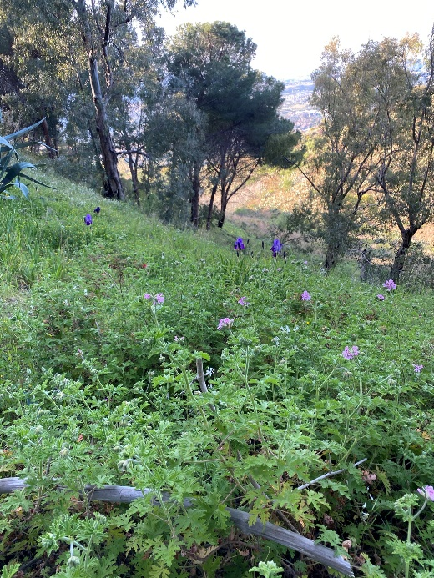

Fig. 22a,b Pelargonium graveolens (Thunb.) L’Hér. in the pine forest on the Pentimele hill, Reggio Calabria (Reggio Calabria province) - Ph. VLAL.
- Phytolacca dioica L.
Phytolaccaceae, Neophyte, S. America, Scapose Phanerophyte
First record for Calabria (casual)
Specimen: 10 May 2021, Italo Falcomatà Seafront, Reggio Calabria (Reggio Calabria province), in the middle of the hedge of Pittosporum tobira (Thunb.) W.T.Aiton, 38.114143°N - 15.650012°E, 23 m a.s.l., leg. et det. V.L.A. Laface (REGGIO).
Note. The observed plants grow among the hedges of Pittosporum tobira (Thunb.) W.T.Aiton and in the cracks sidewalk (Fig. 23a,b). They probably originated from seeds of ornamentals plants grown nearby. In Italy this species is reported as casual in Toscana, Campania, Puglia, Sardegna and is naturalized in Sicily (Galasso et al. 2018a).
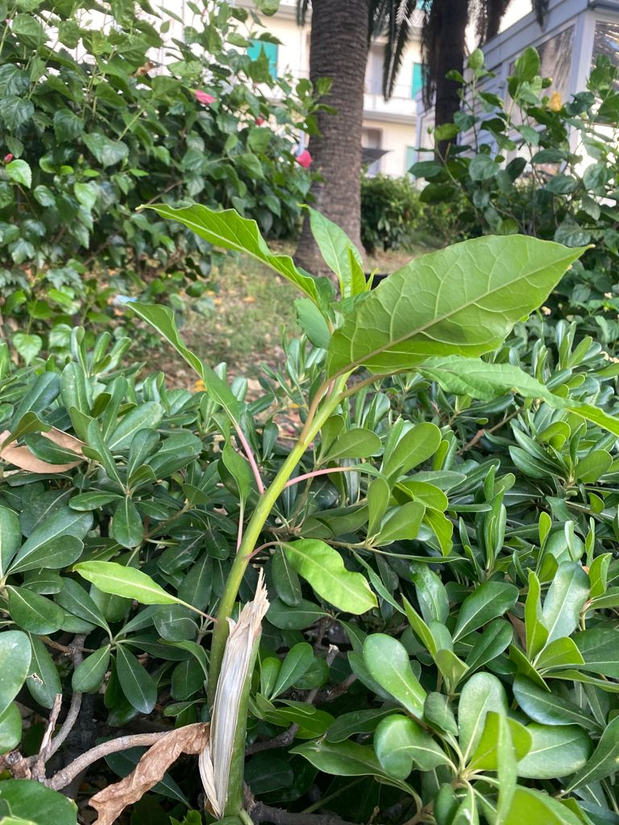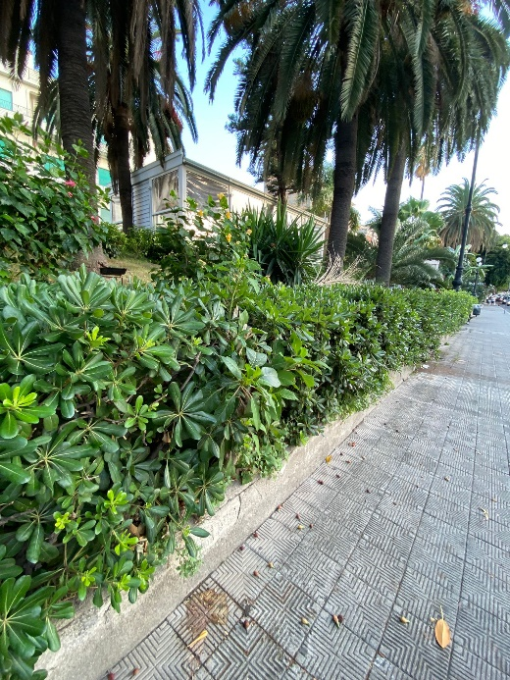

Fig. 23a,b Phytolacca dioica L. among the hedges of Pittosporum tobira (Thunb.) W.T.Aiton in Reggio Calabria seafront (Reggio Calabria province) - Ph. VLAL.
- Portulaca umbraticola Kunth [Portulaca coronata Small; Portulaca lanceolata Haw.]
Portulacaceae, Neophyte, Mexico to Tropical America, Reptant Therophyte
First record for Calabria (casual)
Specimen: 5th November 2020, Lazzaro (Reggio Calabria province), gutter, 37.974283°N-15.665122°E, 19 m a.s.l., leg. C.M. Musarella, det. V.L.A. Laface, C.M. Musarella (REGGIO); 5th November 2020, Lazzaro (Reggio Calabria province), crack in a sidewalk, 37.974200°N- 15.665040°E, 19 m a.s.l., leg. C.M. Musarella, det. V.L.A. Laface, C.M. Musarella (REGGIO) (Fig. 24a,b).
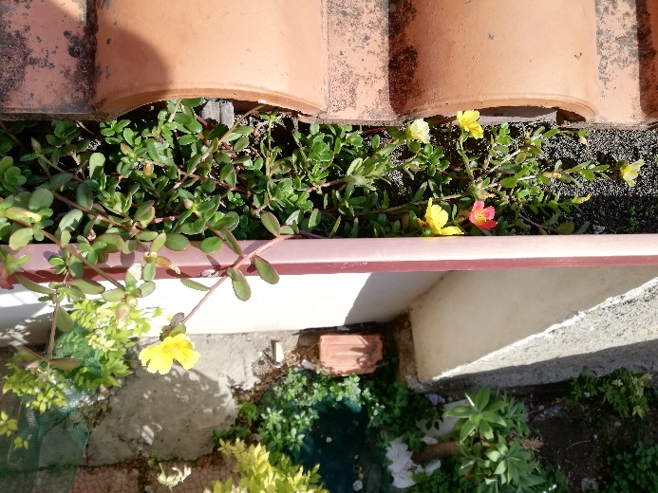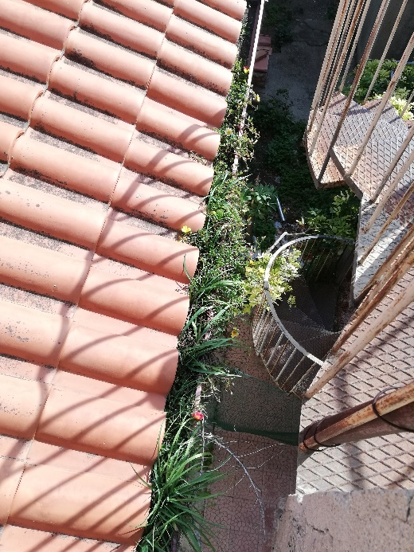

Fig. 24a,b Portulaca umbraticola Kunth in a gutter in Lazzaro of Motta San Giovanni (Reggio Calabria province) - Ph. CMM.
Note. Species of tropical origin cultivated as ornamental plant for its very striking and colourful flowers. According to Galasso et al. (2018a) the species is reported exclusively for Emilia Romagna as casual alien.
- Schinus terebinthifolia Raddi
Anacardiaceae, Neophyte, Brazil to Northeast Argentina, Scapose Phanerophyte
First record for Italian Peninsula (casual)
First record for Calabria (casual)
Specimen: 16th January 2021, Via Secondaria, Archi, Reggio Calabria (Reggio Calabria province), roadside, 38.156614°N-15.661306°E, 28 m a.s.l., leg. et det. V.L.A. Laface (REGGIO).
Note. The numerous plants observed come from seeds produced by street trees (Fig. 25a,b). In Italy, this species is reported as casual alien exclusively in Sardegna (Galasso et al. 2018a).
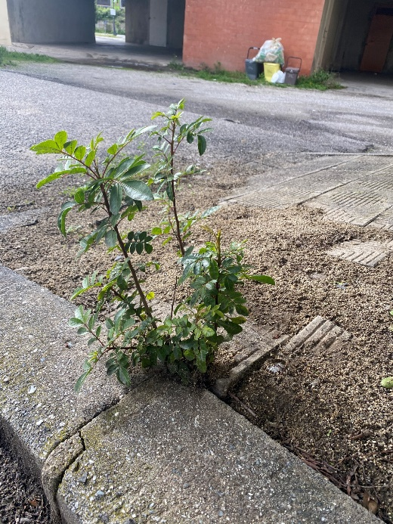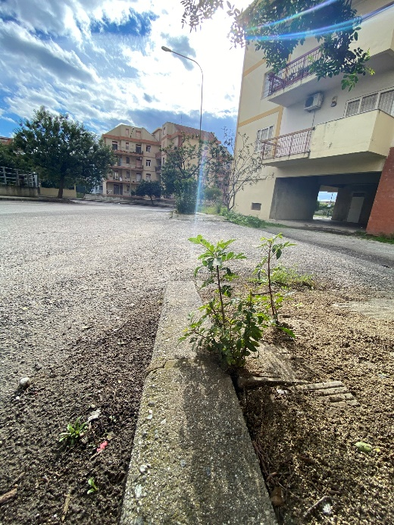

Fig. 25a,b Schinus terebinthifolia Raddi along a street in Archi, Reggio Calabria (Reggio Calabria province) - Ph. VLAL.
- Talinum paniculatum (Jacq.) Gaertn. [Portulaca paniculata Jacq.]
Talinaceae, Neophyte, Tropical and Subtropical America, Succulent Chamaephyte
First record for Calabria (casual)
Specimina: 24th June 2020, Via Sacchi, Reggio Calabria (Reggio Calabria province), sidewalk, 38.120864°N-15.659211°E, 46 m a.s.l., leg. et det. V.L.A. Laface (REGGIO); 12th January 2021, Via Nazionale, Catona (Reggio Calabria province), side walk, 38.186272°N-15.644117°E, 12 m a.s.l., leg. et det. V.L.A. Laface (REGGIO).
Note. The individuals observed grow in the sidewalk cracks, from seeds of ornamental cultivated plants nearby (Fig. 26a,b).
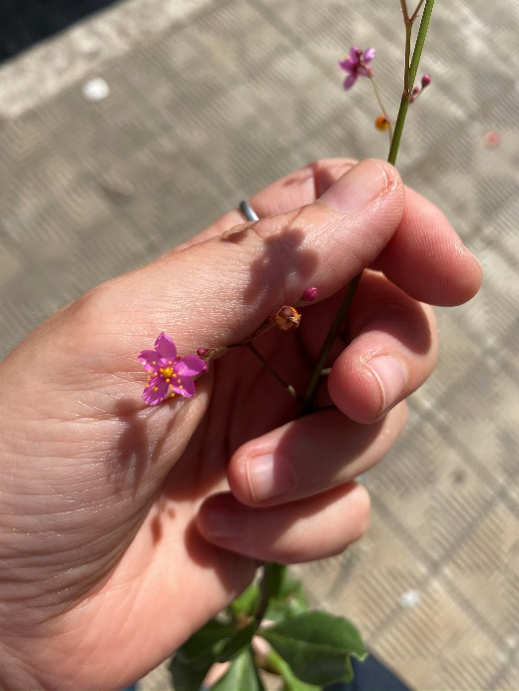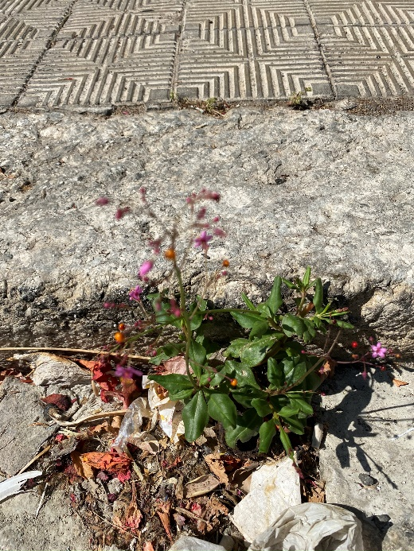

Fig. 26a,b Talinum paniculatum (Jacq.) Gaertn. on a sidewalk in Reggio Calabria (Reggio Calabria province) - Ph. VLAL.
- Tecomaria capensis (Thunb.) Spach [Bignonia capensis Thunb.; Tecomia capensis (Thunb.) Lindl.]
Bignoniaceae, Neophyte, Tanzania to South Africa, Climbing Phanerophyte
First record for Calabria (casual)
Specimina: 13th January 2021, Via Petrello, Santa Trada, Villa San Giovanni (Reggio Calabria province), climbing on a wire mesh / roadside, 38.241406°N-15.676989°E, 67 m a.s.l., leg. et det. C.M. Musarella (REGGIO) (Fig. 28a,b); 30 April 2021, Via Miniera, Gallina, Reggio Calabria (Reggio Calabria province), road side escarpment, 38.088064°N-15.674489°E, 208 m a.s.l., leg. et det. V.L.A. Laface (REGGIO).
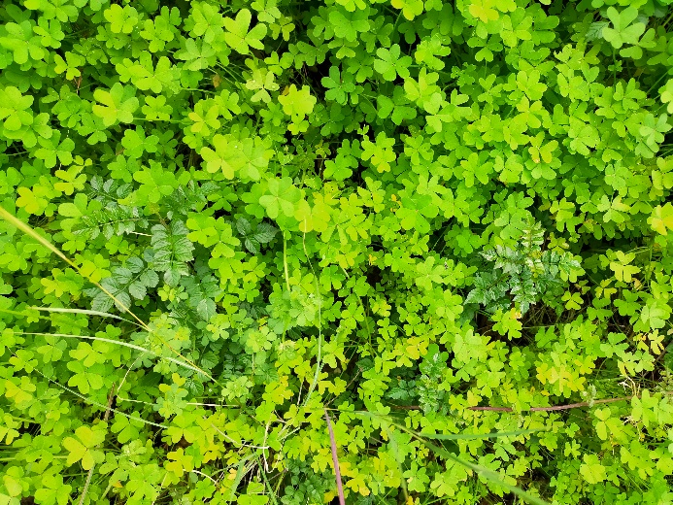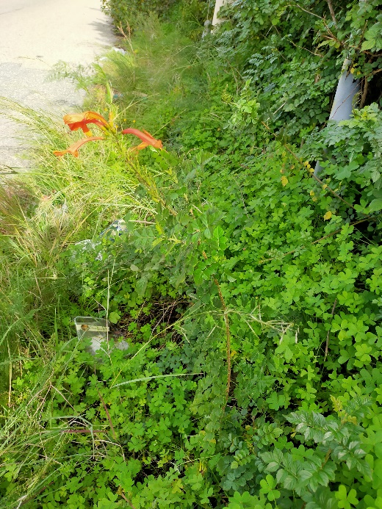

Fig. 27a,b Tecomaria capensis (Thunb.) Spach along Petrello Street in Santa Trada of Villa San Giovanni (Reggio Calabria province) - Ph. CMM.
Note. Climbing plant, with very striking orange flowers, typically used to cover fences and pergolas. In Italy, this species is reported as casual alien in Sardegna, Sicilia, Puglia and Toscana (Galasso et al. 2018a).

